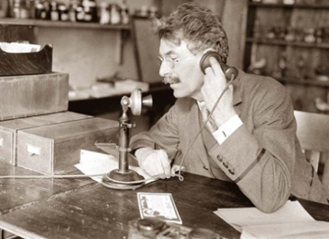 |  | 
Verleden tijd | Tegenwoordige tijd | Toekomst
Past | PRESENT | Future
Past Simple | Present Simple | Will/ Shall
Present Perfect | Present Continuous | Going to

Present Simple | Present Continuous
When
Gewoontes of feiten: | Als iets nu, op dit moment aan de gang is
Nooit
Altijd
Regelmatig
Rule
WW  WW + S = (SHIT rule) | am / are / is + ww + ing
Uitzonderingen She/ He/ It: | Uitzonderingen spelling
Do en Go → +es  (Go) He goes to the movies. | WW eindigt op –e → e valt weg + ing  (Have) I am having the biggest party ever!
WW eindigt op sisklank → +es  (Watch) She watches horror movies. | WW eindigt op klinker + medeklinker → dan medeklinker verdubbelen  (Get) It is getting dark outside.
WW eindigt op medeklinker+y → y wordt ies
(Carry) The dog carries the stick.
How
I work | I am working
You work | You are working
S / H / It works | S / H / It is working
We work | We are working
They work | They are working
Signifier
Never | Now
Always | Right now
Often | At the moment
Sometimes | Currently
Usually | Look!
Every week
Frequently
Present Simple

- Fill in the correct form of the verb (ww) in the gap.
- We always (sprint) ____________________ when we see pie.
- He (hide) ____________________ from zombies in his closet at the moment.
- The Avengers (stop) ____________________ evil from happening.

B. Only level 4 students
Some verbs take a different spelling when the subject is She/ He/ It. With the
help of the rules on the next page, give the correct spelling for these words.
- Catch =
- Enjoy =
- Go =
- Carry =
- Fly =
- Pay =

Present Continuous

C. Circle the correct form of the Present Continuous.
- Marieke am / are / is noticing how the sun is shining now.
- At the moment we am / are / is answering questions.
- You am / are / is making no mistakes currently.
- I am / are / is talking to the classroom right now.
- Macklemore is on the radio now: “This am / are / is f*cking awesome!”

Present Simple or Present Continuous

D. In each sentence, underline the signifier and circle whether the present simple
(PS) or the present continuous (PC) is used.
- I usually go to bed before 11.30 PS / PC
- She is cleaning her room right now. PS / PC
- Water boils at 100 degrees Celsius. PS / PC
- You cannot see him now; he is having a discussion with his boss. PS / PC
- I am working at the moment. PS / PC

E. Circle the correct form of the verb.
- Regular customers sometimes are getting / get a discount.
- I am not working / do not work on Saturdays.
- Where is the manager? He is talking / talks to a customer.
- In a department store I always am taking / take the escalator.
- The summer sale is starting / starts on July 1st.
- He always is travelling / travels business class.
- I cannot help you; I am making / make a phone call.

F. Give the correct form of the verb (present simple or continuous) between brackets.
- Right now I (watch) ____________________ a movie.
- Dyllan (be) ____________________ my friend.
- We (like) ____________________ to talk together.
- He never (buy) ____________________ his clothes alone.
- Lysa usually (eat) ____________________ cold cereal for breakfast.
- My uncle (live) ____________________ in Tennessee.
- My mom (cook) ____________________ dinner at the moment.
- A butcher (sell) ____________________ meat.
- The Thames (flow) ____________________ through London.
- We (read) ____________________ the newspaper every morning.
- She (kiss) ____________________ her boyfriend like there is no tomorrow now.
- I (run) ____________________ because there’s a bloody big bear after me!
- That cop is so uncool. He always (flash) ____________________ his badge.
- I never (crash) ____________________ into things with my bike.
- Apples are crucial! I (bake) ____________________ you a pie right now!

